These instructions will guide you through the use of the Communication Towers App.
When you open the app, it will appear similar to the following figure.

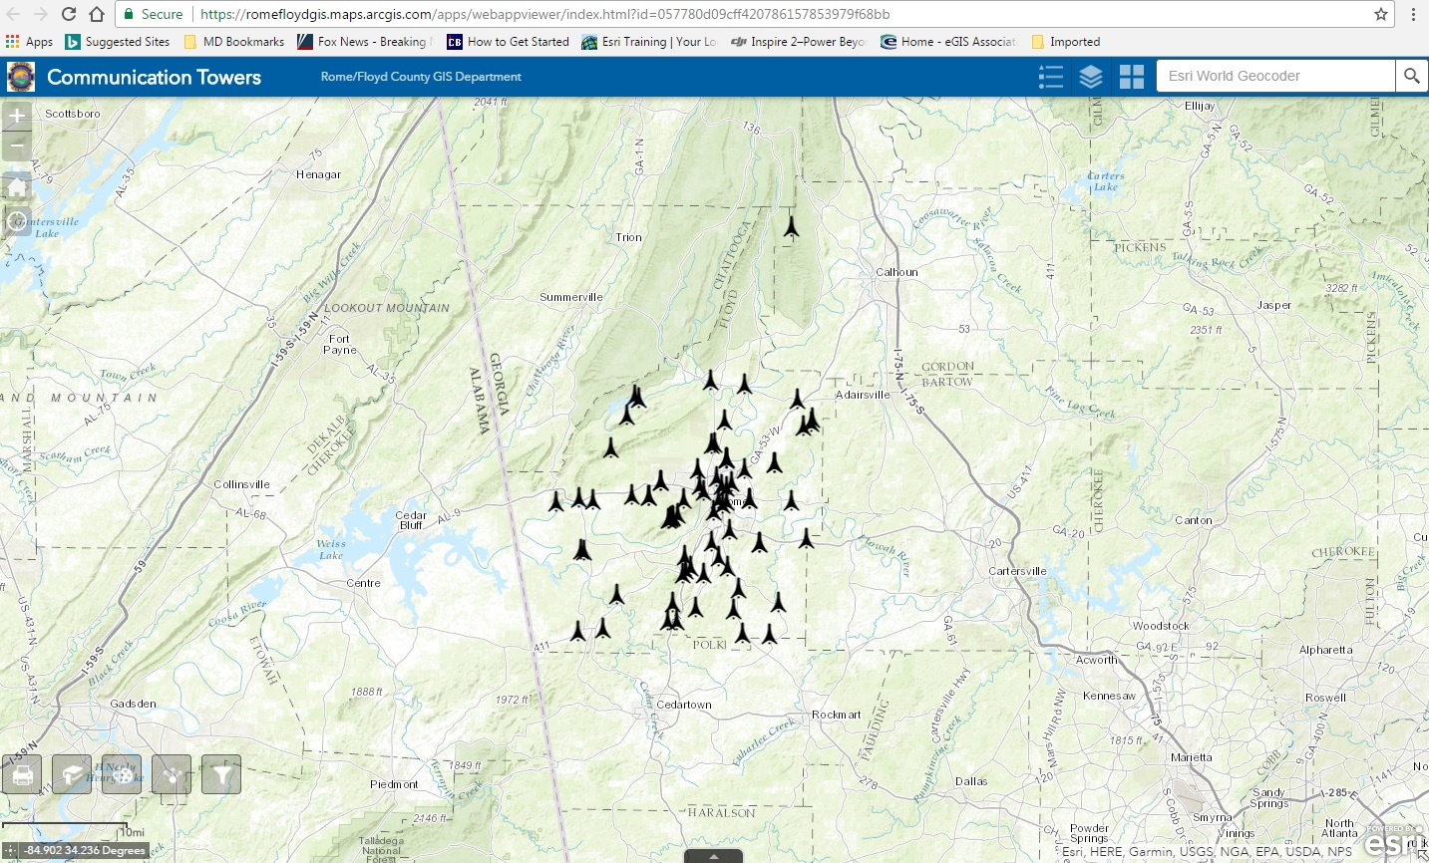
Zoom In

Zoom Out

Home
My Location

Contact Link
Legend
Layer List
Basemap Gallery
Search Tool
Bookmark
Scale Bar
Coordinate Tool

Print
Draw
Share
Filter

Zoom In – This button will zoom in on the center of the map. You can also use the scroll button on your mouse.
Zoom Out – This button will zoom out from the center of the map. You can also use the scroll button on your mouse.
Home – This button will return you to the original extent of the map.
My Location – This button will display your location on the map.
Contact Link – This link will take you to the Rome/Floyd County GIS page where you can find contact information.
Legend – This button will allow you to view the map legend.
Layer List – This will display all the layers available on the map. You can turn them on or off depending on your need. Current layers associated with this map are: Communication Towers, US and State Highways, Roads, City and County Boundaries, and Zoning.
Basemap Layer – This allows you to toggle between backgrounds such as: topographic (set as default), street maps, or imagery.
Search Tool – This will allow you to search for addresses.
Print – Prints your current map extent.
Bookmark – Use this tool to set place holders for locations you wish to get back to quickly.
Draw – This tool allows you to add polygons, lines, points and text to your map.
Share – Use this tool to share the app.
Filter – This tool has pre-set filters to help you navigate the map more easily. Pre-set filters include tower owners and zoning.
Scale Bar – This allows you to make measurements on the map
Coordinate Tool – This tool allows you to click a point on the map and get the coordinates for that location.

As you zoom in on the map, the tower owners will appear beside each tower. If you click on a tower, a pop-up will appear that gives you general information about that tower. There will also be a link for FCC_SEARCH that displays as “More info”. Clicking on this link will take you to the Federal Communications Commission (FCC) website where you can find more detailed information about that particular tower.

